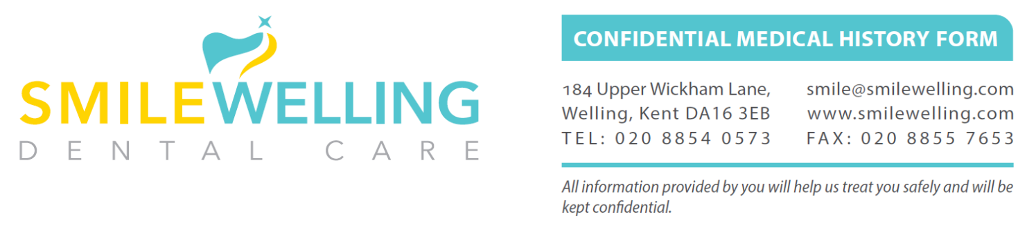

Title | Name | Surname
Gender | Date Of Birth | NHS Number
Tel Home | Tel Mobile | Tel Work
Address
Email (REQUIRED)
Occupation | GP Name and Address
I am happy to receive/ communication Text/Email/Letter | Patients under 16 - Parental responsibility (Both parents),  If not please state who has parental responsibility below
Emergency contact Person | Phone Number | Relationship to me

Continue overleaf.

CURRENT CONDITIONS & ALLERGIES | Yes | No | Unsure
Are you carrying a medical warning card?
Are you receiving treatment from a doctor, hospital or clinic?
Are you pregnant?
Are you allergic to any medicines (e.g., Penicillin), general or local anaesthetics, substances (e.g., latex/rubber), or foods?
Do you suffer from hay fever, any skin diseases or eczema?
MEDICINES & TREATMENTS
Are you taking any (self-) prescribed medicines (e.g., tablets, ointments, injections, inhalers, eyedrops, suppositories, nebulisers, the contraceptive pill or HRT)?
Have you ever had a steroid treatment?
DO YOU SUFFER FROM
Any heart problems, angina, heart murmur, high blood pressure or have you ever had a stroke?
Bruising or persistent bleeding following injury, surgery or tooth extraction?
Bronchitis, asthma or any other chest condition?
Any infectious diseases (e.g., HIV, hepatitis, TB)?
Diabetes?
Kidney or liver diseases (e.g., jaundice, hepatitis)?
Neurological / nerve diseases (e.g., neuropathy, MS, chorea) or fainting attacks, giddiness or epilepsy?
Arthritis or rheumatic fever?
Muscle problems (e.g., myopathy, dystrophy, paralysis)?
Stomach, ulcers, hiatus hernia, or indigestion?
Any other serious illnesses?
SURGICAL & HOSPITAL STAYS
Have you ever had a heart or brain surgery?
Have you had a joint replacement or any other implant?
Have you ever been treated in a hospital?
FAMILY HISTORY
Does anyone in your family have diabetes?
Has anyone in your family ever suffered from cancer?
DRINKING, SMOKING & CHEWING
How many units of alcohol do you drink per week? (1 unit = half pint of lager or one shot of spirits or a single glass of wine/aperitif)
Do you smoke or chew tobacco products now? Or did you in the past?
If so please state how many per day
Do use Vape/e-cigarettes?

Continue overleaf.
Please list any additional details to the previous questions:
Please list any self-prescribed medication (e.g., aspirin)
Please list any medication prescribed by your doctor (REQUIRED)

VISITS TO YOUR DENTIST
How do you feel when visiting a dentist? | Anxious | Nervous | Relaxed
When did you last visit a dentist?

Are there any dental procedures, which have frightened you in the past, or which make you nervous?
Are there any cosmetic treatments you have considered?

I confirm that I have read the above and filled in this form to the best of my ability.
Completed By (Type in Box) Self/Parent/Guardian/Dentist
Signed (Type Name Below) | Date

